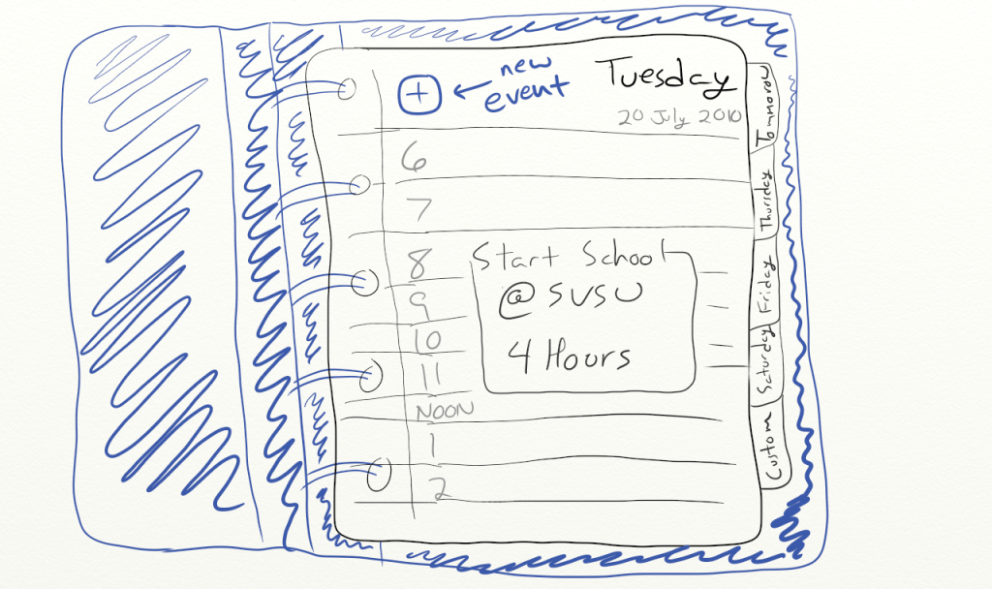

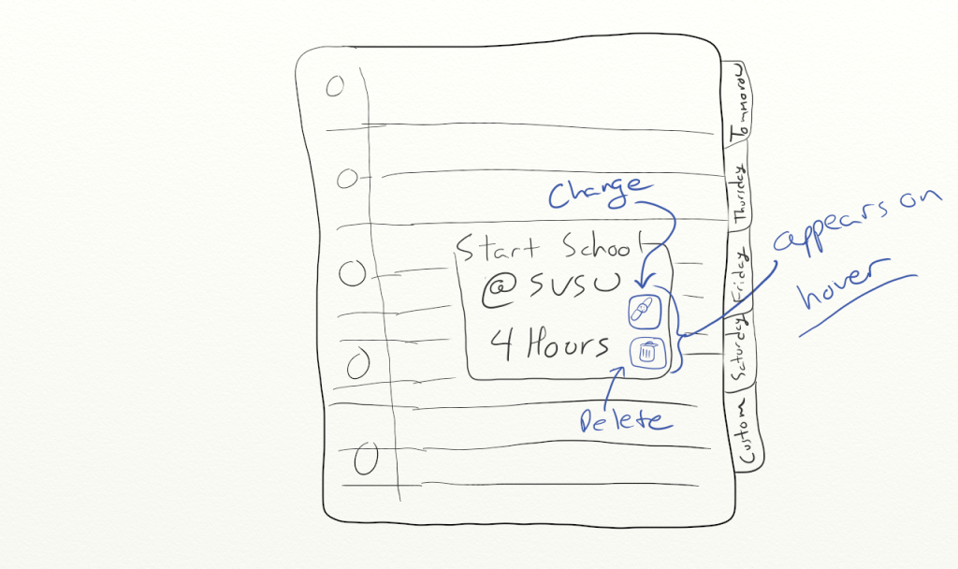

I'm seeing a need for 4 php scripts: addEvent.php,

Called by an ajax request with a posted JSON object describing the event. Adds the given event to the database, then r
responds with a boolean true/false indicating success.
removeEvent.php,

Called by an ajax request with an event ID. Deletes the event from the database, then responds with a true/false indicating success.
updateEvent.php,

Called by an ajax request with a JSON object containing 1) the event ID of the event being updated and 2) a standard event object like the one used in addEvent.php. Updates the event in the database and responds with true/false indicating success.
and fetchMonth.php

Called by an ajax request with 1 GET argument indicating the month requested. Could respond with either:
- JSON object representing an entire month worth of events, the actual generation of xhtml would then be done on the client-side by javascript

I find this method more interesting, since I've already done the other for another project.
- The final XHTML code that represents the month. In this case, the generation of xhtml would be done by the php script.
Either way is doable. Having the php generate the xhtml is arguably a tiny bit easier, but not by much.
I just wanted to post some thought on a table.
Event is the table name
Rows
EventNumber 3 or 4 digit number
Day(mon tues weds ) or (1,2,3)
StartTime
EndTime
Date ( or Month, day, Year)
EvanetName ( CHAR(10) meeting, class, seminar, ext)
Detail (CHAR(40) Location, and other information)
EventNumber would be that key or drop EventNumber and use date and StartTime together as a key. A single key would be easier to work with. I am open for thoughts

